OS LAB 4
ROUND ROBIN SCHEDULING :

#include <stdio.h>
struct Process
{
int at, bt, rt;
int ct, tat, wt, resp;
int visited;
};
int main()
{
struct Process p[20];
int queue[100];
int n, tq;
int front = 0, rear = 0;
int time = 0, completed = 0;
float avgwt = 0, avgtat = 0, avgrt = 0;
printf("Enter number of processes: ");
scanf("%d", &n);
for(int i = 0; i < n; i++)
{
printf("Enter Arrival Time and Burst Time for P%d: ", i + 1);
scanf("%d %d", &p[i].at, &p[i].bt);
p[i].rt = p[i].bt;
p[i].resp = -1;
p[i].visited = 0;
}
printf("Enter Time Quantum: ");
scanf("%d", &tq);
queue[rear++] = 0;
p[0].visited = 1;
while(completed != n)
{
int i = queue[front++];
if(p[i].resp == -1)
p[i].resp = time - p[i].at;
if(p[i].rt > tq)
{
time += tq;
p[i].rt -= tq;
}
else
{
time += p[i].rt;
p[i].rt = 0;
p[i].ct = time;
completed++;
}
for(int j = 0; j < n; j++)
{
if(p[j].at <= time && p[j].visited == 0)
{
queue[rear++] = j;
p[j].visited = 1;
}
}
if(p[i].rt > 0)
queue[rear++] = i;
printf("\nReady Queue: ");
for(int j = front; j < rear; j++)
printf("P%d ", queue[j] + 1);
}
printf("\n\nPID\tAT\tBT\tCT\tTAT\tWT\tRT\n");
for(int i = 0; i < n; i++)
{
p[i].tat = p[i].ct - p[i].at;
p[i].wt = p[i].tat - p[i].bt;
avgwt += p[i].wt;
avgtat += p[i].tat;
avgrt += p[i].resp;
printf("P%d\t%d\t%d\t%d\t%d\t%d\t%d\n",
i + 1, p[i].at, p[i].bt, p[i].ct,
p[i].tat, p[i].wt, p[i].resp);
}
printf("\nAverage Turnaround Time = %.2f", avgtat / n);
printf("\nAverage Waiting Time = %.2f", avgwt / n);
printf("\nAverage Response Time = %.2f\n", avgrt / n);
return 0;
}

OUTPUT
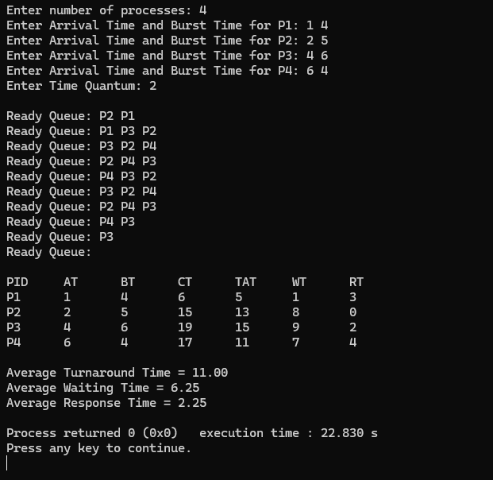
MULTILEVEL SCHEDULING:

#include <stdio.h>
struct Process
{
int pid;
int at;
int bt;
int type; // 0 = System, 1 = User
int ct;
int tat;
int wt;
};
int main()
{
struct Process p[20];
int n, i, time = 0;
int sys[20], user[20];
int sc = 0, uc = 0;
printf("Enter number of processes: ");
scanf("%d", &n);
for(i = 0; i < n; i++)
{
printf("\nProcess %d\n", i + 1);
p[i].pid = i + 1;
printf("Arrival Time: ");
scanf("%d", &p[i].at);
printf("Burst Time: ");
scanf("%d", &p[i].bt);
printf("Type (0=System, 1=User): ");
scanf("%d", &p[i].type);
if(p[i].type == 0)
sys[sc++] = i;
else
user[uc++] = i;
}
for(i = 0; i < sc; i++)
{
int k = sys[i];
if(time < p[k].at)
time = p[k].at;
time += p[k].bt;
p[k].ct = time;
p[k].tat = p[k].ct - p[k].at;
p[k].wt = p[k].tat - p[k].bt;
}
for(i = 0; i < uc; i++)
{
int k = user[i];
if(time < p[k].at)
time = p[k].at;
time += p[k].bt;
p[k].ct = time;
p[k].tat = p[k].ct - p[k].at;
p[k].wt = p[k].tat - p[k].bt;
}
printf("\nPID\tAT\tBT\tTYPE\tCT\tTAT\tWT\n");
for(i = 0; i < n; i++)
{
printf("%d\t%d\t%d\t%d\t%d\t%d\t%d\n",
p[i].pid, p[i].at, p[i].bt, p[i].type,
p[i].ct, p[i].tat, p[i].wt);
}
return 0;
}
OUTPUT:
